**The Parish of St. Matthew, Abbotsford**

**Anglican Church of Canada**

**August 21, 2022**

**The Eleventh Sunday after Pentecost**

**Service of the Word**

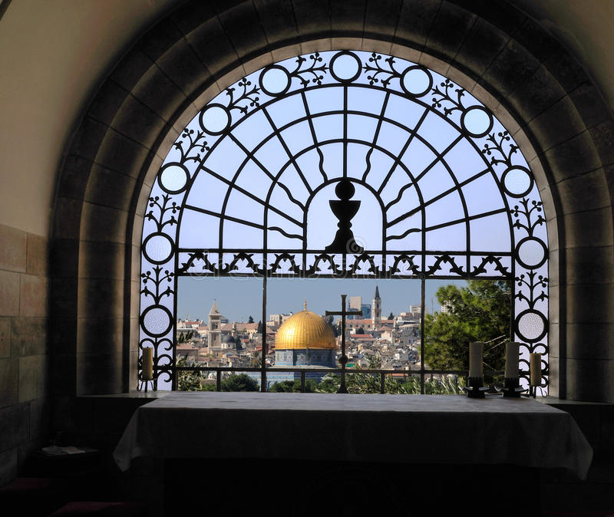

**11:00 AM**

**The Book of Alternative Services**

***Helping each other explore God's Beauty, Truth and Goodness***

Officiant Dick Martin

Greeter/ Sidesperson Bob B.

Musician Lloyd B. and co.

Counters Ike E./Trevor S.

AV Operator Belinda K.

Announcements

**The Gathering of the Community**

**Greeting**

Officiant: Lord, open our lips,

**People: And our mouth shall proclaim your praise.**

Officiant: O God, make speed to save us.

**People: O Lord, make haste to help us. Alleluia**

Opening Hymn …………*O For a Thousand Tongues to Sing…………………..* CP 306

O for a thousand tongues to sing my dear Redeemer’s praise,

the glories of my God and King, the triumphs of his grace.

Jesus! the name that charms our fears, that bids our sorrows cease;

‘tis music in the sinner’s ears, ‘tis life, and health, and peace.

He speaks, and, listening to his voice, new life the dead receive,

the mournful broken hearts rejoice, the humble poor believe.

Hear him, ye deaf, ye voiceless ones, your loosened tongues employ

ye blind, behold your Saviour come, and leap, ye lame, for joy!

My gracious Master and my God, assist me to proclaim,

to spread thro’ all the earth abroad the honours of thy name.

**Collect for Purity**

**Officiant*:*** Almighty God,

***All:* to you all hearts are open, all desires known,**

**and from you no secrets are hidden.**

**Cleanse the thoughts of our hearts**

**by the inspiration of your Holy Spirit,**

**that we may perfectly love you,**

**and worthily magnify your holy name;**

**through Christ our Lord. Amen.**

Song of Praise…….…  *Glorious Things of Thee are Spoken*…….……………….CP 388

(vs. 1-3)

Glorious things of thee are spoken,

Zion, city of our God;

he whose word cannot be broken

formed thee for his own abode.

On the rock of ages founded,

what can shake thy sure repose?

With salvation’s walls surrounded,

thou mayest smile at all thy foes.

See! The streams of living waters,

springing from eternal love,

well supply thy sons and daughters

and all fear of want remove.

Who can fain, when such a river

ever flows their thirst to assuage?

Grace, which like the Lord, the giver,

never fails from age to age?

Round each habitation hovering,

see the cloud and fire appear

for a glory and a covering –

showing that the Lord is near.

Thus they march, the pillar leadings,

light by night and shade by day;

daily on the manna feeding

which God gives them when they pray*.*

**Collect of the Day**

Officiant: God of the Sabbath,

**All: this is the day and this is the hour**

**when women long oppressed stand with dignity,**

**and when your healing escapes our desire for control:**

**may your joy stretch the fabric of our hearts**

**and inspire us to loosen each other’s bonds;**

**through Jesus Christ, the shamer of the powerful**

**and the raiser of the dead. Amen.**

*Prayers for an Inclusive Church (2009) alt.*

**The Proclamation of the Word**

***Officiant:*** The night has passed, and the day lies open before us; let us pray with one heart and mind.

As we rejoice in the gift of this new day, so may the light of your presence, O God, set our hearts on fire with love for you; now and forever.

***All:* Amen.**

First Reading……………………… Jeremiah 1:4-10……….………….……….…Ike E.

***Reader:***  *Hear what the Spirit is saying to the Church.*

***All: With your help, O Lord, we will listen and live.***

**Psalm 71** *In te, Domine, speravi*

1. In you, O Lord, have I taken refuge; *

**let me never be ashamed.**

2. In your righteousness, deliver me and set me free; *

**incline your ear to me and save me.**

3. Be my strong rock, a castle to keep me safe; *

**you are my crag and my stronghold.**

4. Deliver me, my God, from the hand of the wicked, *

**from the clutches of the evildoer and the oppressor.**

5. For you are my hope, O Lord God, *

**my confidence since I was young.**

6. I have been sustained by you ever since I was born;

from my mother’s womb you have been my strength; *

**my praise shall be always of you.**

**Glory to the Father, and to the Son, and to the Holy Spirit, as it was in the beginning, is now, and ever shall be, world without end. Amen.**

Second Reading……………….…….   Hebrews 12:18-29......................................Ike E.

***Reader:*** *Hear what the Spirit is saying to the Church.*

***All: With your help, O Lord, we will listen and live.***

Gradual Hymn ………………  *For All Your Blessings.................................*CP 536

(*vss 1 & 2 before the Gospel, vs 3 after)*

1 Singing songs of expectation,  
Onward goes the pilgrim band,  
Through the night of doubt and sorrow,  
Marching to the promised land.  
Clear before us through the darkness  
Gleams and burns the guiding light:  
Trusting God we march together  
Stepping fearless through the night.

2 One the light of God's own presence,  
O'er his ransomed people shed,  
Chasing far the gloom and terror,  
Bright'ning all the path we tread:  
One the object of our journey,  
One the faith which never tires,  
One the earnest looking forward,  
One the hope our God inspires.

***Reader:***The Lord be with you.

***People*: And also with you.**

***Reader:***The Holy Gospel of our Lord Jesus Christ according to Luke.

***People:***  **Glory to you, Lord Jesus Christ**

Gospel…………………………Luke 13:10-17 *Linda B.*

***Reader:***The Gospel of Christ

***People:* Praise to you, Lord Jesus Christ**

3 One the strain the lips of thousands  
Lift as from the heart of one;  
One the conflict, one the peril,  
One the march in God begun:  
One the gladness of rejoicing  
On the far eternal shore,  
Where the one almighty Father  
Reigns in love for evermore.

**Message** Dick M.

**Affirmation of Faith**

Officiant***:*** Let us confess the faith of our baptism, as we say,

**All:I believe in God,**

**the Father almighty,**

**creator of heaven and earth.**

**I believe in Jesus Christ, his only Son, our Lord.**

**He was conceived by the power of the Holy Spirit**

**and born of the Virgin Mary.**

**He suffered under Pontius Pilate,**

**was crucified, died, and was buried.**

**He descended to the dead.**

**On the third day he rose again.**

**He ascended into heaven,**

**and is seated at the right hand of the Father.**

**He will come again**

**to judge the living and the dead.**

**I believe in the Holy Spirit,**

**the holy catholic Church,**

**the communion of saints,**

**the forgiveness of sins,**

**the resurrection of the body,**

**and the life everlasting. Amen.**

**Prayers of the People** Virginia H.

**Confession and Absolution**

Officiant: Let us confess our sins against God and our neighbour.

*Silence is kept*

**All: Most merciful God,**

**We confess that we have sinned against you**

**in thought, word, and deed,**

**By what we have done and by what we have left undone.**

**we have not loved you with our whole heart;**

**we have not loved our neighbours as ourselves.**

**We are truly sorry and we humbly repent.**

**For the sake of your Son Jesus Christ,**

**have mercy on us and forgive us,**

**that we may delight in your will, and walk in your ways,**

**to the glory of your name. Amen**

Officiant: Almighty God have mercy upon us

Pardon and deliver us from all our sins,

Confirm and strengthen us in all goodness,

And keep us in eternal life;

Through Jesus Christ our Lord.

**All: Amen**

**The Peace**

Officiant: The peace of the Lords be always with you.

**All: And also with you.**

Offertory Hymn……..........*Jesu, Jesu, Fill Us with Your Love**…….………...*..CP 504

(Vs 1-3)

***Refrain***

***Jesu, Jesu, fill us with your love,***

***show us how to serve the neighbours we have from you.***

*Kneels at the feet of his friends,*

*silently washes their feet,*

*master who acts as a slave to them.*

***Refrain***

*Neighbours are rich and poor,*

*varied in colour and race,*

*neighbours are near and far away.*

***Refrain***

*These are the ones we should serve,*

*these are the ones we should love;*

*all these are neighbours to us and you.*

***Refrain***

**Prayer over our Tithes and Offerings**

Officiant: God of heaven and earth,

receive our sacrifice of praise,

and strengthen us

for the perfect freedom of your service,

through our Saviour Jesus Christ.

**Prayer for Sundays**

Officiant: Father of light,

**All: yours is the morning and yours is the evening.** **Let Christ, the Sun of righteousness, shine for ever in our hearts and draw us to that light where you live in radiant glory. We ask this for the sake of Jesus Christ our Lord. Amen.**

**The Lord’s Prayer**

Officiant: Gathering our prayers and praises into one, let us pray as our Saviour taught us,

**All: Our Father in heaven,**

**hallowed be your name,**

**your kingdom come, your will be done,**

**on earth as in heaven.**

**Give us today our daily bread.**

**Forgive us our sins,**

**as we forgive those who sin against us.**

**Save us from the time of trial,**

**and deliver us from evil.**

**For the kingdom, the power,**

**and the glory are yours,**

**now and for ever. Amen.**

**Blessing**

Officiant: The Lord bless us and keep us. The Lord make his face shine on us and be gracious to us. The Lord look upon us with favour and grant us peace.

**All: Amen**

Recessional Hymn…………….*The Love of Jesus Calls Us* …..……………..CP 434

The love of Jesus calls us our joyous praise to sing;

our deeply felt thanksgivings we now together bring,

for all God’s many blessings, unasked yet still received,

and for the generations who faithfully believed.

The love of Jesus calls us, that we may always be

companions on a journey, where all the world may see

that serving Christ is freedom which time does not destroy;

where Christ’s command is duty, and every duty joy.

The love of Jesus calls us to go where he would go,

to challenge all that limits, to change, to learn, to grow,

to know that Christ has freed us, that prisons are no more;

for those who seek his kingdom, Christ opens every door.

The love of Jesus calls us in swiftly changing days,

to be God’s co-creators in new and wondrous ways;

that God with men and women may so transform the earth,

that love and peace and justice may give God’s kingdom birth.

**The Sending**

Officiant: Let us bless the Lord!

**People: We will bless you O Lord with all our hearts!  Alleluia!**

**ANNOUNCEMENTS**

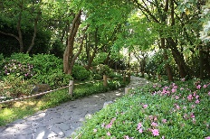

**Tuesday** 12:15-12:30 pm **15 minutes for Peace** at the Friendship Garden behind theClearbrook Library.

Unable to attend, take a moment to think about peace wherever you are.

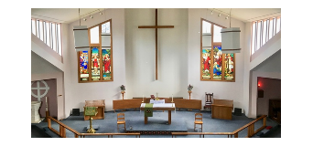

**Our worship schedule will be changing on September 1.**

The 2nd and 5th Sunday of the month will be Service of the Word.

The 1st, 3rd, and 4th Sundays will be Holy Eucharist.

**Wednesday Evening Study**: We'll be starting a book study on N.T. Wright's *Broken Signposts: How Christianity Makes Sense of the World*  as a Zoom study.  Here's a link to where you can find the book on Amazon <https://amzn.to/3QycJHL>  but you can find the book in many places.  **If you're interested please order the book asap.  We will begin, Wednesday, September 14th at 7 pm.  Fr. Allen will send out a Zoom link as we get closer.**



**St. Matthew News** If you are not receiving ‘Midweek Updates’

and other St. Matthew information and would like to be added

to the email list, kindly send a request to [church@abbotsfordanglican.ca](mailto:church@abbotsfordanglican.ca).



**Saturday, September 17, 3-4pm (ish).**  YOU’RE INVITED to

TEA: at Peace Lutheran Church on Ware St. at Marshall Rd.

Enjoy German and Scandinavian sweets as a treat for the

Archway Food Bank contest. Let the parish office know

([church@abbotsfordanglican.ca](mailto:church@abbotsfordanglican.ca)) by September 10 that you are planning to attend this fun activity with our friends at Peace.  Children welcome.

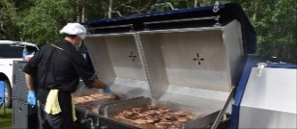

**Sunday, September 18** St. Matthew day celebration with Holy Eucharist, a barbecue, and activities for the children.

**Saturday, September 24** DiocesanACW meeting at St. Mathew.

**The Parish of St. Matthew**

**Anglican Church of Canada**

**Diocese of New Westminster**

2010 Guilford Drive

Abbotsford, BC V2S 5R2

Office Phone: 604-853-2416

Email: [church@abbotsfordanglican.ca](mailto:church@abbotsfordanglican.ca)

Website: [www.abbotsfordanglican.ca](http://www.abbotsfordanglican.ca)

**Follow us on social media**

facebook.com/abbotsfordanglican

@abbyanglican

**Bishop:** The Rt. Rev. John Stephens

**Priest:** Father Allen Doerksen

[allen@abbotsfordanglican.ca](mailto:allen@abbotsfordanglican.ca)

Fr. Allen’s Cell (text and phone) 604-302-1082

**Parish Council:** Father Allen Doerksen

Tyler Evans– Rector’s Warden, Synod Delegate

Trish Martin– People’s Warden, Alternate Synod Delegate

Kerri Onken – Treasurer

Ike Ezema – Member-at-Large

Dick Lee – Member-at-Large

Trevor Smale – Member-at-Large

**Envelope Secretary:** If you are interested in this position, please speak to Fr. Allen